- Check the info. of html from the following website
http://www.w3schools.com/html/html_intro.asp
- Go through topics in the left column for HTML Introduction, Editors, Basic and Elements

- What is an HTML Tag?

An HTML tag is a Hypertext Markup Language tag that describes different elements of a website, which includes the content.

- What is a markup tag?

A markup tag is used to describe, structure and link different elements of a website.

Check the following code:
<!DOCTYPE html>
<html>
<head>
<title>Page Title</title>
</head>
<body>
<h1>My First Heading</h1>
<p>My first paragraph.</p>
</body>
</html>
Explain what each markup tag does.

The <!DOCTYPE html> tag declares what type of file this is (HTML in this case).
The <html> and </html> tags start and end the entire document.
The <head> and </head> tags start and end the heading of file. Code nested inside of these tags is not displayed on the actual web page.
The <title> and </title> tags change the title of the website (the text that appears as the tab name in a web browser) to whatever is set between the tags.
The <body> and </body> tags start and end the body of the document. Code nested inside of these tags is the actual content of the document and is the only content that appears on the webpage as viewed from a conventional browser.
The <h1> and </h1> tags are used to describe the text between the tags as heading one text to the browser. This is the largest and most important heading size, going all the way down to heading six, being the least important.
The <p> and </p> tags are used to describe the text between the tags as paragraph text.

- Why should we use web browsers?

We should use web browsers because they make is possible to quickly read through websites and view content efficiently. Websites interpret various coding languages such as HTML, CSS, PHP, etc. as a modern website. Without web browsers, not only would we have to learn all the different coding languages fluently, but we would also have to spend hours just reading one webpage, translating each line one by one.

- What is the <!DOCTYPE> Declaration?

The <!DOCTYPE> declaration is a representation of the file type, helping the web browser interpret the code.

- List and define the 7 basic HTML Tags.

The <!DOCTYPE html> tag declares what type of file this is (HTML in this case).
The <html> and </html> tags start and end the entire document.
The <head> and </head> tags start and end the heading of file. Code nested inside of these tags is not displayed on the actual web page.
The <title> and </title> tags change the title of the website (the text that appears as the tab name in a web browser) to whatever is set between the tags.
The <body> and </body> tags start and end the body of the document. Code nested inside of these tags is the actual content of the document and is the only content that appears on the webpage as viewed from a conventional browser.
The <h1> and </h1> tags are used to describe the text between the tags as heading one text to the browser. This is the largest and most important heading size, going all the way down to heading six, being the least important.
The <p> and </p> tags are used to describe the text between the tags as paragraph text.

- What are HTML documents are made up by?

HTML stands for Hypertext Markup Language, therefore, HTML documents are made of markup tags. Markup tags describe the content of the document, in a way that a web browser can interpret it in order to display a web page.

- What are HTML elements?

HTML elements are markup tags that consist of a start and end tag.
- Are HTML tags case sensitive?

HTML tags are not case sensitive; however many programmers recommend using lowercase rather than capital because many other languages demand that the code be lowercase. These languages include XHTML and Turing.

- Give three examples of Empty HTML Elements.

- <br>
- <hr>
- <img src=”source.jpg”>
- <meta charset=”UTF-08”>
- <link rel=”spreadsheet” src=”style.css” type=”text/css”/>

- Create an HTML file that looks like this:
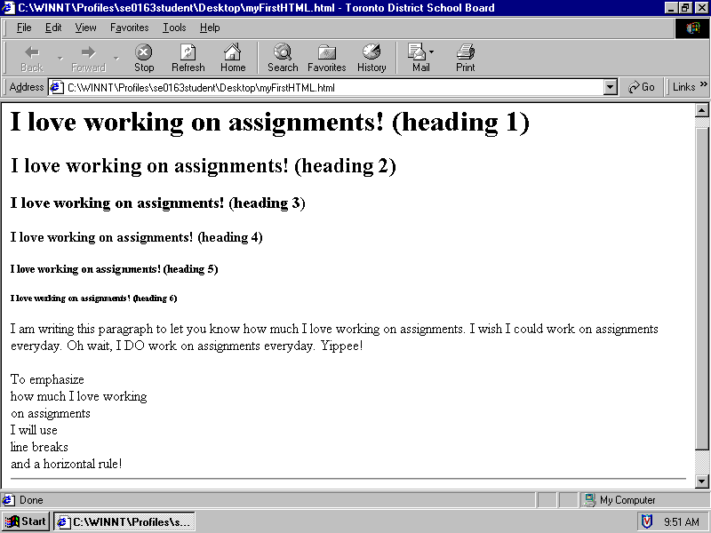
Have your html file separately; save as Q10.html

